Name – VED KHODE
PRN - 25070521176
3.1.2 CELSIUS TO FAHRENHEIT
ALGORITHM
- Start
- Input temperature in Celsius (C)
- Calculate Fahrenheit using the formula
F = (C × 9/5) + 32
- Display Fahrenheit value (formatted to 2 decimal places)
- End
FLOWCHART
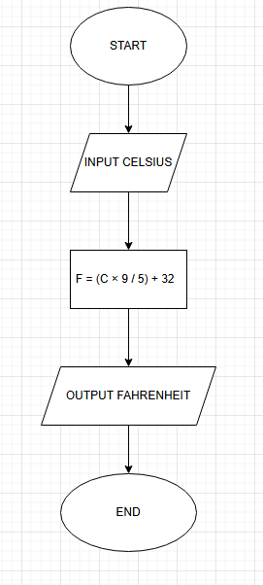
Code –
celsius = float(input())
fahrenheit = (celsius * 9 / 5) + 32
print(f"{fahrenheit:.2f}")

PROGRAM
